EAST COLUMBIA BASIN IRRIGATION DISTRICT RESOLUTION 2024 - 10
SURPLUS OFFICE EQUIPMENT

WHEREAS, the East Columbia Basin Irrigation District has various items of equipment, more particularly described herein, which the Directors unanimously agree and are no longer useable by the District; and

WHEREAS, the District must dispose of such property in accordance with the provisions of RCW 87.03.135; and

NOW, THEREFORE, BE IT RESOLVED that the following described equipment be declared surplus and otherwise disposed of.

Asset | Description | Serial Number
OFF-2200-014 | Copier | RRB08497
OFF-2200-015 | Copier | RKF03054
OFF-2200-016 | Copier | RKM07888
OFF-2200-016 | Copier | RKJ24685

DULY ADOPTED in Open Meeting by the Board of Directors this 3rd day of April,

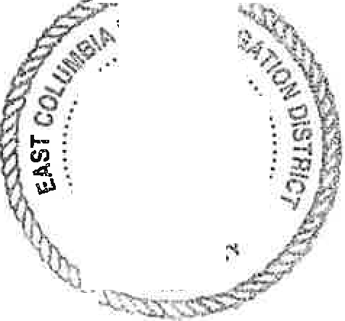2024. ,--(.
13 S!N IR.9.
..... ·R-i ANi>.:;._
()
.
d b=, ·*'- .I£...J
..·..
....
·
... ,;, :·:Ji-t
··., " ,::zg .. · ·
.

,-s 7'.'•

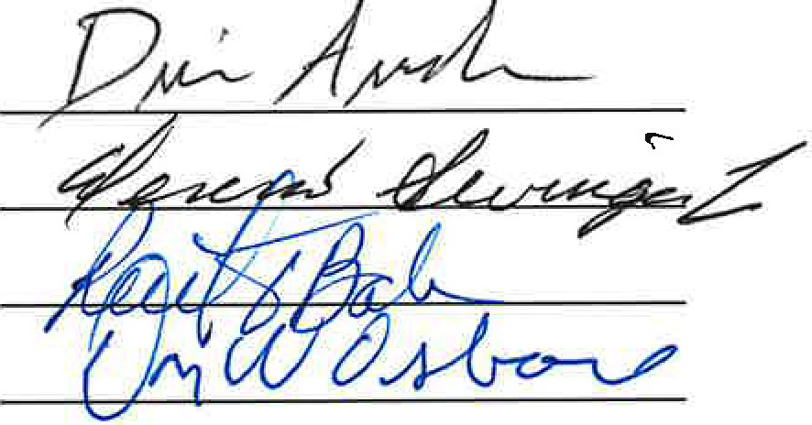
BOARD OF DIRECTORS

